Abstract

AI technology has greatly changed the traditional way traditional businesses operate. AI tools, especially AI image generation techniques, helps companies generate high-quality content rapidly with lower labour and cost.

Although the image generation technique has already achieved significant results and has been widely used in the market, it is very struggle for the video generation field. As the generation model could not understand the relation between the figure and the background, it usually provides a poor performance in the video generation tasks. Specific problems are found in the poor clarity of the hourly reviews, faulty object interaction logic, noticeable background noise, and poor image consistency.

In this project, we aim to provide a new way to generating the video not using video generating model, but text-to-image (T2I) diffusion model. Specifically, we learn a new way to enhance the consistency between images generating by different iterations, then they can be merged into a video.

**C**

**ontents**

Chapter 1: Introduction 5

1.1 Background 5

1.1.1 Ai video generation in market 5

1.1.2 Problems about available ai video generation model 6

1.1.3 Problems about available ai image generation model 7

1.1.4 Summary 7

1.2 Problem Statement 8

1.2.1 Limited computation resources 8

1.2.2 Inaccurate detail control 8

1.2.3 Inconsistency between frames 10

1.3 Aim 10

1.4 Objectives 12

1.4.1 To find an appropriate text-to-image model as a base model 12

1.4.2 To achieve accurate detail control ability 12

1.4.3 To achieve accurate pose control ability 12

1.4.4 To achieve the consistency between frames 12

1.5 Research Questions 12

1.6 Report Structure 13

Chapter 2: Literature Review 14

Chapter 3: Design and Analysis 15

3.1 Base Model Analysis 15

3.1.1 Generative Adversarial Networks (GANs) 15

3.1.2 Variational Autoencoders (VAEs) 15

3.1.3 Diffusion Models 15

3.1.4 Transformer-based Models 15

3.1.5 Summary 15

3.2 Detail Control 15

3.2.1 Text Prompt 15

3.2.2 Image Control 16

3.2.3 Fine Tune 16

3.3 Pose Control Analysis 16

3.3.1 Text Prompt 16

3.3.2 Pose Image 16

3.4 Consistency Control 17

Chapter 4: Implementation 18

4.1 Base Model Implementation 18

4.2 Details Control Implementation 18

4.3 Pose Control Implementation 20

4.4 Consistency Implementation 21

4.4.1 Similar Latent 21

4.4.2 Cross-Frame Attention 23

4.5 Summary 24

Chapter 5: Improvement 25

5.1 Better Prompt 25

5.2 Pose Skeleton with Face 26

Chapter 6: Evaluation 27

Chapter 7: Conclusion 28

7.1 Outcomes 28

7.2 Existing Problems 28

7.3 Future Works 29

Appendix A - Example 30

Additional Appendices (as needed) 32

Software 32

Hardware 32

Model 32

Introduction

Recently, AI image generation technology has achieved remarkable results. Among these, the Diffusion model stands out as one of the most powerful text-to-image (T2I) models, capable of generating realistic and impressive images with high levels of creativity and control over image details. In contrast, text-to-video (T2V) technology still faces significant limitations. The primary challenge is that video generation models must comprehend the relationship between backgrounds and figures to produce logical actions, necessitating extensive computational resources and high-quality datasets.

This project aims to enhance the quality and consistency of generated images and to improve the ability to replicate specific details accurately, addressing these critical gaps in image synthesis technology.

## Background

The field of generative modeling has witnessed significant advancements, particularly in producing realistic images. The advent of AI technologies like Stable Diffusion and ControlNet has pioneered new avenues for creating highly realistic and diverse images. This project leverages these advancements, aiming to expand the limits of what is achievable in image synthesis.

Ai video generation in market

Creating videos, even those as brief as 10 seconds, can be exceedingly expensive. Professional video production typically incurs costs ranging from $800 to $4,000 per finished minute, depending on factors such as the type of video, length of the shoot, use of special effects, and crew size. Even the simplest videos may cost approximately $500 for a one-minute segment. More complex productions, such as car commercials, can exceed $500,000 for just a 30-second clip. Moreover, hiring a basic crew for a small-scale production may cost between $500 and $2,000 per day​​.

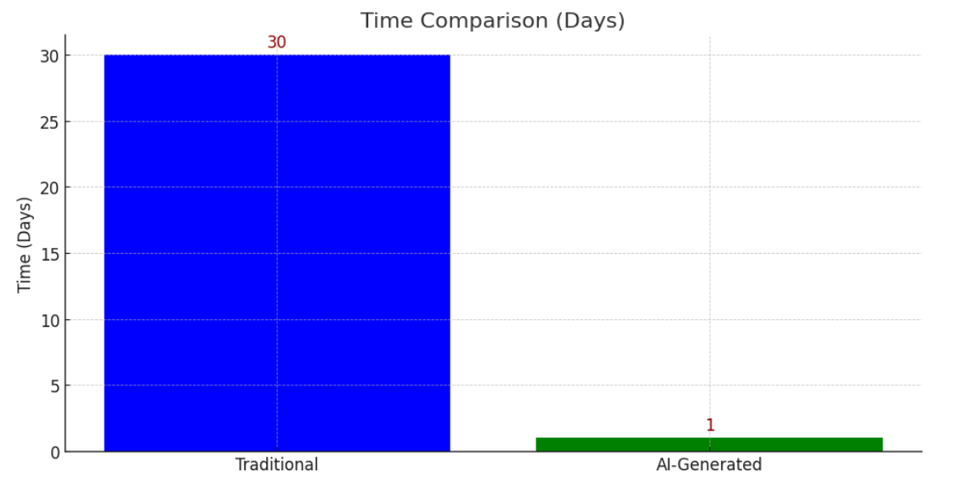

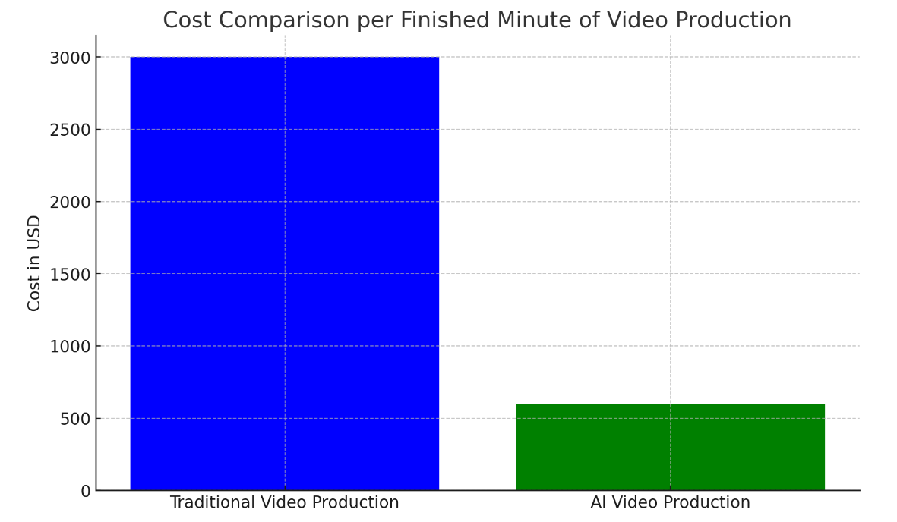

Figure 1 (the comparison between traditional video production and AI video production)

Data from (<https://bluecarrot.io/blog/the-future-of-video-production-with-ai-opportunities-challenges-and-real-cases>)

Problems about available ai video generation model

Artificial intelligence (AI) generation technology is extensively utilized in the film and television industry, primarily for background and character replacement, as well as special effects creation. However, current video generation technologies face several challenges:

**Complexity**: Effective video generation requires understanding the temporal coherence and dynamics of objects within scenes, including consistent changes in lighting, perspective, and movement across frames.

**Computational Resources**: Videos model often requires significant processing power and memory.

**Data Requirements**: Training such models requires large amounts of high quality video data, which are more difficult to acquire than image data.

**Quality and Resolution**: Achieving and maintaining high quality and resolution video frames is challenging, particularly with respect to detail and consistency.

**Detail Control:** It is currently difficult or even impossible to replicate specific poses and intricate details such as facial features, clothing, and backgrounds with complete accuracy.

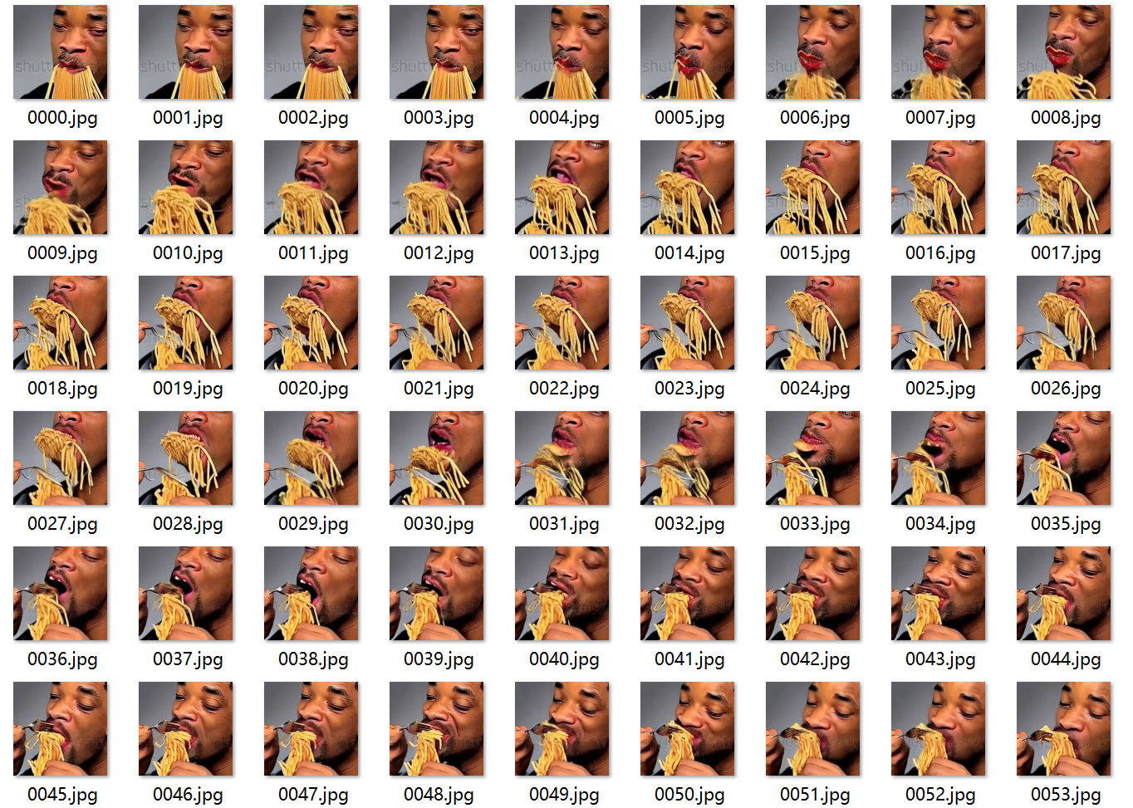

*Figure 2, Image frames generated by available video generation model.*

Video from ([AI-generated video of Will Smith eating spaghetti astounds with terrible beauty | Ars Technica](https://arstechnica.com/information-technology/2023/03/yes-virginia-there-is-ai-joy-in-seeing-fake-will-smith-ravenously-eat-spaghetti/))

Problems about available ai image generation model

Even the technology of image generation is advanced, it is still struggling to meet some of the user's needs below:

**Consistency between Frames:** Keeping the same background or the same figure seems impossible for the generation model as the model do not actually understand the logic and the object in real world. There would hard for model to know which should be kept and which should be changed.

**Accurate Detail Control:** Generating process greatly depends on the text prompt, so whether a prompt is good or not determines the quality of the generated image. However, many details are difficult to be summarised and described in words, and it is even more difficult for the models do not fully comprehend the meaning behind the prompts.

Summary

All in all, producing a video using existing AI techniques remains a complex and costly task, involving significant time and resources for location preparation, filming, video optimization, and communication.

For companies and individuals, the ability to generate images with high consistency and exact detail from an input style could enhance customization options and reduce costs.

If it is possible that we can provide a video generating model with highly flexible and accurate details control, which the company only needs a few people to use to generate the initial video and hand it over to the video post-processing team for restoration. It could help companies to further improve efficiency and save costs. And for a companies and individuals, such high consistency images can also help them to further customise and replace details.

## Problem Statement

Several challenges must be addressed to develop a text-to-video (T2V) generation model.

Limited Computation Resources

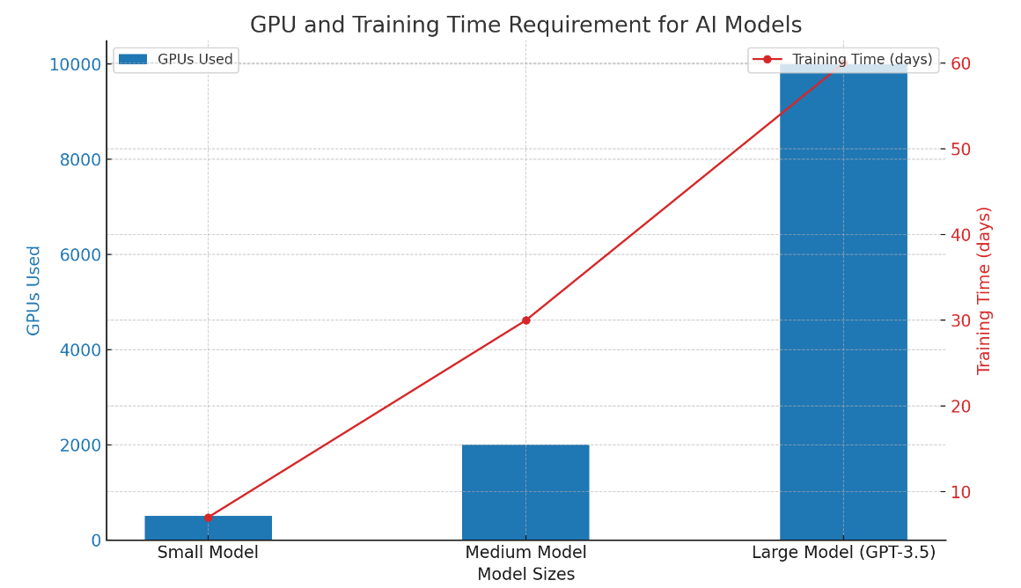As the project aims to provide a video generating model. The primary problem in developing a video generation model is the immense computational resources required. This constraint makes it impractical for most students, companies, and individuals to train a T2V model. Below, we detail the resource requirements for training a large-scale model.

Data from (<https://www.fierceelectronics.com/sensors/chatgpt-runs-10k-nvidia-training-gpus-potential-thousands-more>).

As illustrated in the figure, training a large model such as GPT-3.5 requires over 10,000 GPUs for more than 60 days, in addition to a substantial volume of high-quality datasets. A simple text-to-video (T2V) model would likely to require even more resources. Consequently, adapting an existing text-to-image (T2I) model with minimal or no additional training could be the only possible solution.

Inaccurate detail control

There are some model can accept image as input to achieve the detail control ability. Here is an image-to-image model designed to use an image as input and produce a similar output image. The generated image will possess similar structure and color. During the generation process, the model identifies the most relevant sample from its training data to create an image that closely resembles the input.

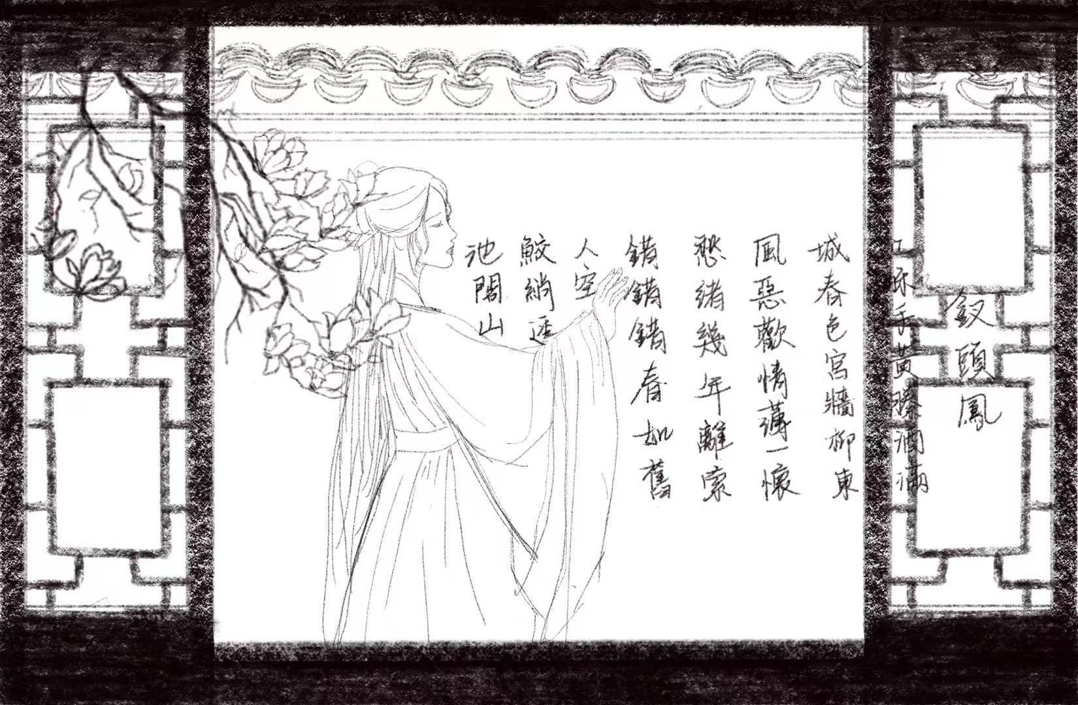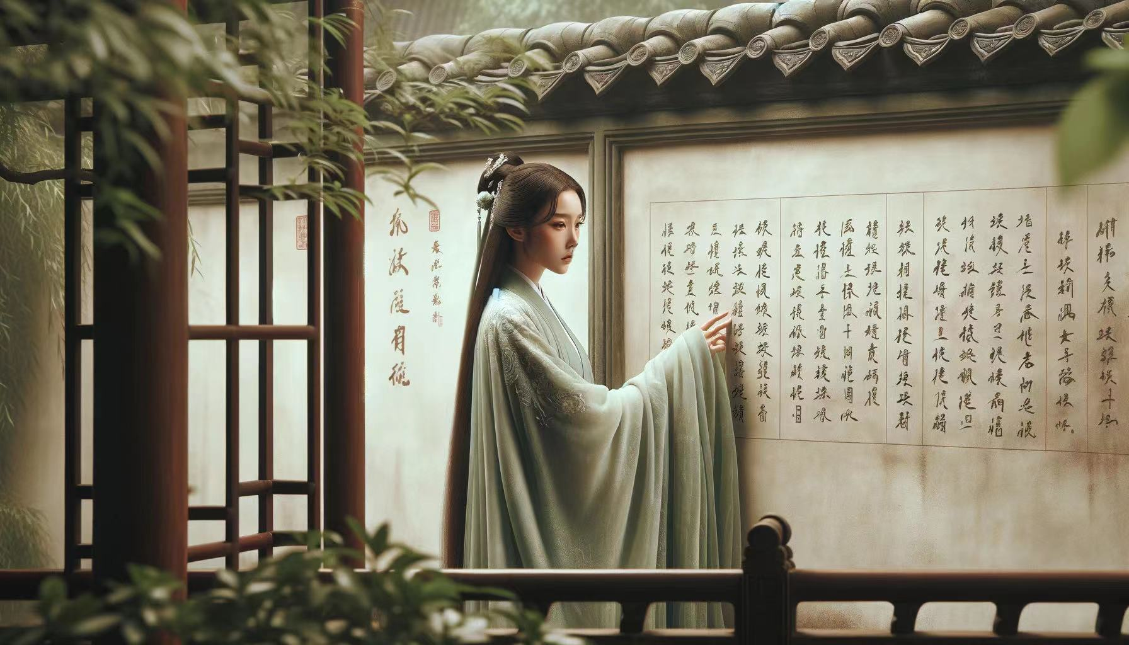Figure 4 and Figure 5 serve as inputs for generating images using existing control tools, resulting in the output shown in Figure 6.

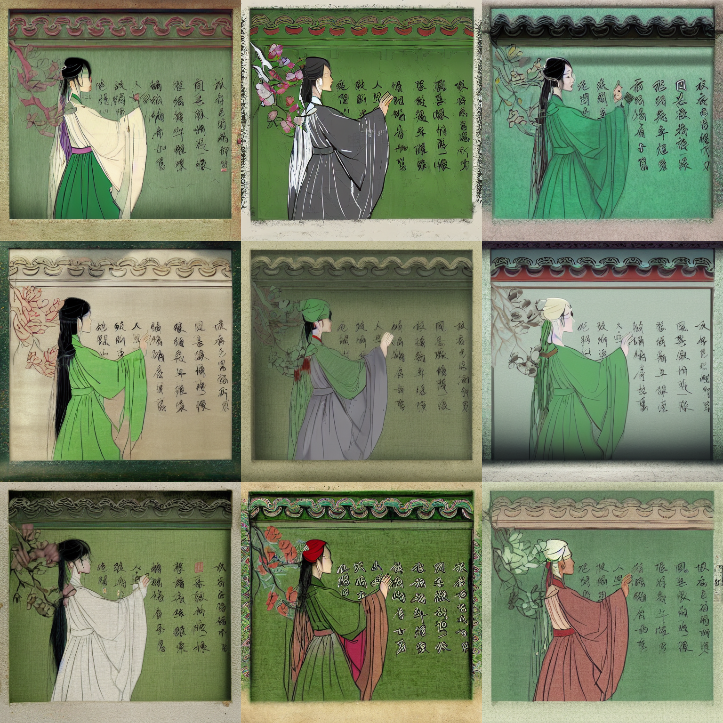Figure 4 Figure 5

Figure 6

We aim for the model to generate images with the structure of Figure 4, incorporating the texture and color of Figure 5. However, the current tools available for controlling detail are unable to accurately reproduce structure, color, and texture. This limitation underscores that accurately reproducing specific details in generated images remains a complex task.

Inconsistency between frames

Figure 7 illustrates how the study 'Tune-A-Video' (Wu et al., 2023) explores video generation by integrating image frames into a coherent video. This paper focuses on replacing figures, employing a video with a text prompt as input to fine-tune an existing text-to-image (T2I) model into a text-to-video (T2V) model. The training process allows the model to retain not only the pre-training data from the initial T2I model but also to learn from the video input. Consequently, the model could generate video frames conditionally, utilizing text prompts as a controlling mechanism.

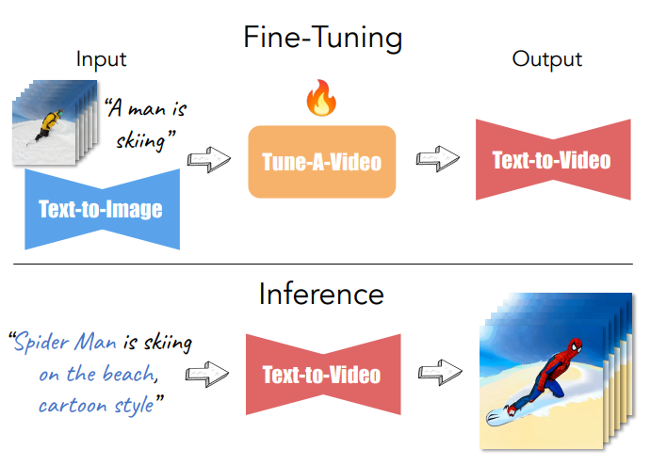

Figure 7. (The generation process of Tune-A-Video)

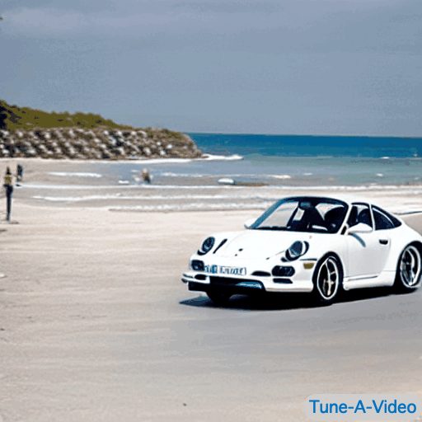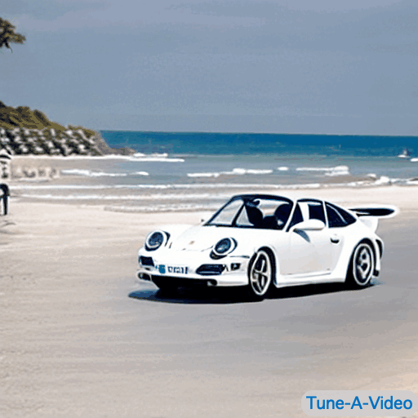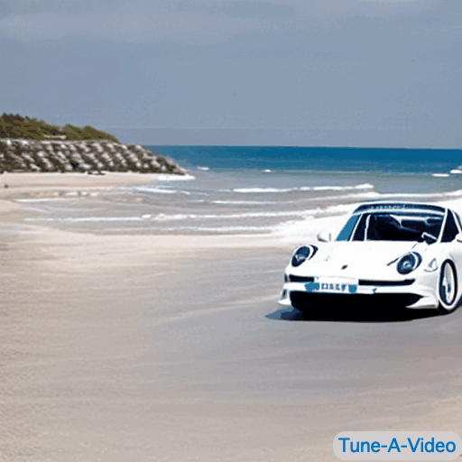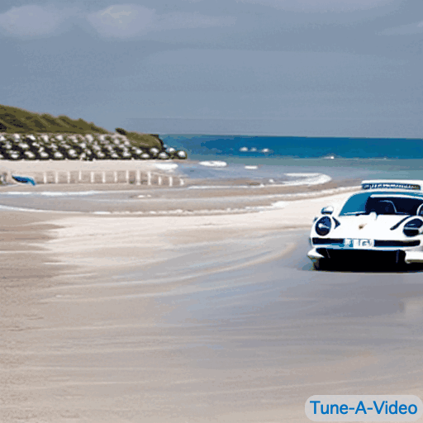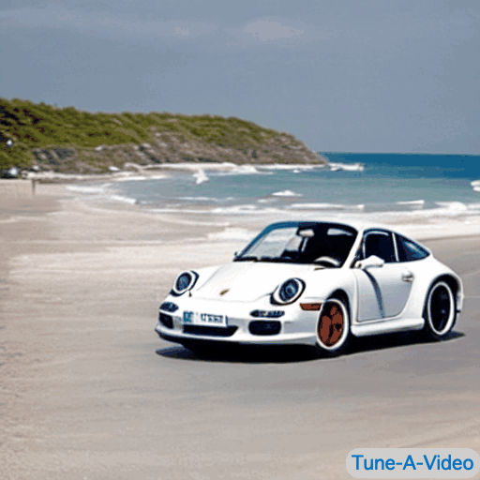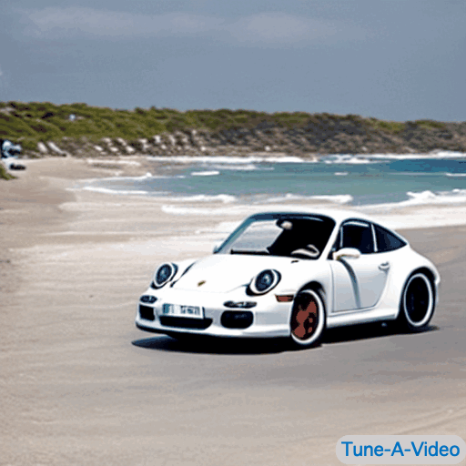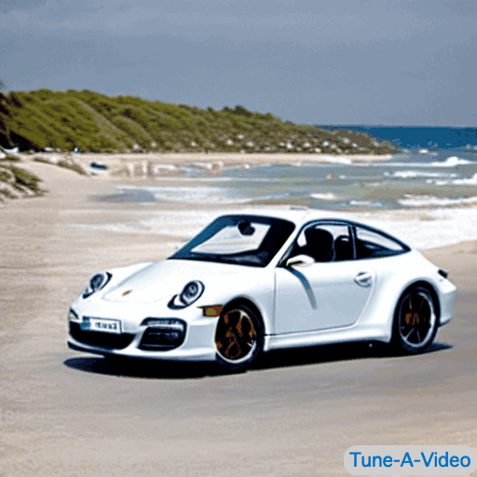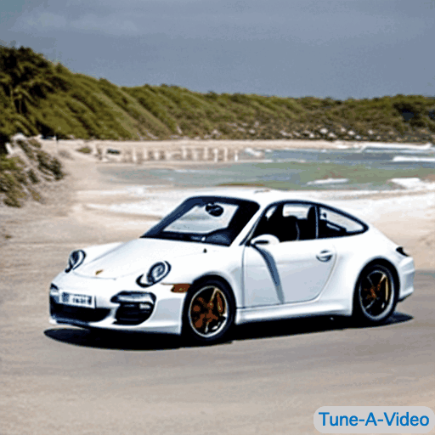Here are some images frames, the images are generated by their text-to-video model.

The model effectively replaces a moving car with a different type of vehicle and alters the background to depict a beach setting. The performance is commendable, as evidenced by the car moving smoothly from a distant to a nearer perspective. However, the consistency of details within each frame is poor; the car's features and the background elements, including sporadic appearances of people, change unpredictably between frames. This inconsistency arises because the model generates each frame independently, lacking awareness of which elements should remain consistent across successive frames. Consequently, this leads to a final video that is noticeably noisy.

## Aim

This project aims to developing a video generation model that allows for customized videos with precise detail control. Moreover, the model aims to produce high-quality videos rapidly and cost-effectively, utilizing limited computing resources. To achieve this, three prevalent issues within existing video generation models must be addressed: the production of low-resolution videos, poor video detail, and the presence of noisy, meaningless backgrounds.

To enhance the quality, we need to fine-tune or training our own video model which is impossible. Consequently, we propose using available state-of-the-art image generation models to create high-quality image frames and then merge them into a video. However, synthesizing videos from static images is impractical due to the absence of temporal and spatial continuity, a major challenge for existing video generation models. To address this, the normal video models require larger architectures and more extensive, high-quality training datasets than image models to grasp the continuity of time and space effectively. So, this project aims to guide image generation by utilizing pose images that provide some temporal and spatial continuity, while trying to generate highly consistent objects, figures, and background in all frames to produce image frames with a degree of temporal and spatial continuity, thus facilitating video generation.

Then we come out the baseline of the project, “Pose-guided Video Generation Model."

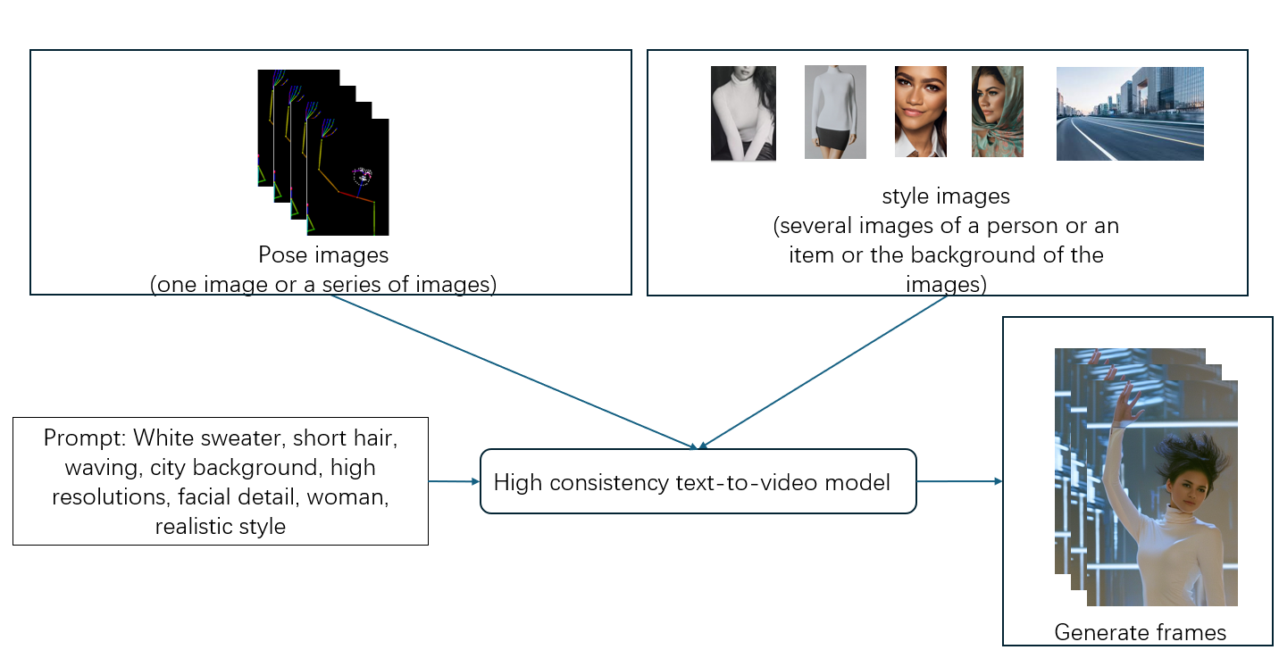

Figure 8 "Pose-guided Video Generation using Diffusion Models”.

Figure 8 presents a concise overview of the 'Pose-guided Video Generation using Diffusion Models' project. This project employs three distinct types of input to achieve precise detail control: pose images, style images, and text prompts. Pose and style images are instrumental in providing specific and accurate control over details such as pose, texture, color, and facial features. Concurrently, the text prompt supplements these images by establishing a basic description for the image generation process.

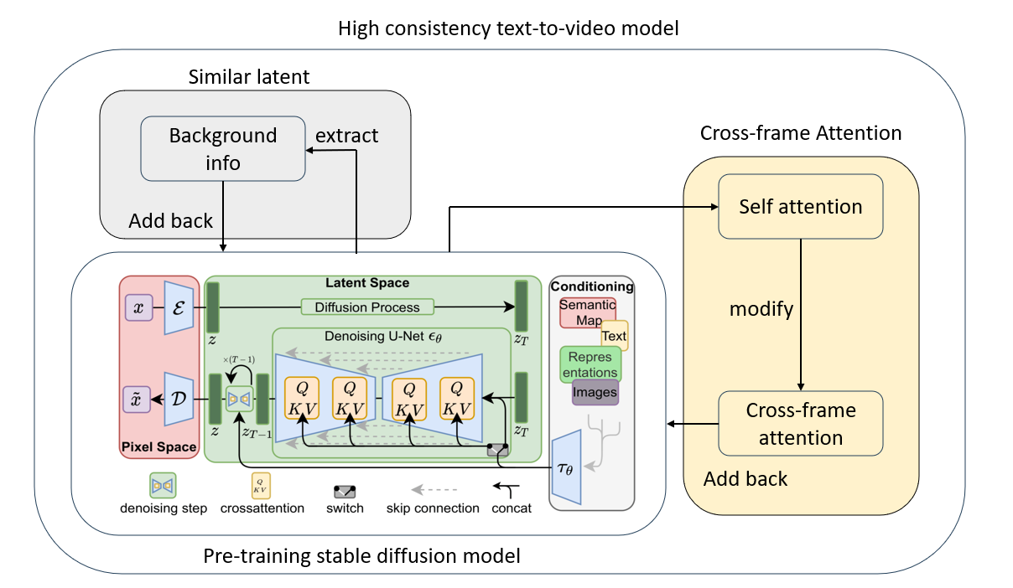

Figure 9 High consistency text-to-video (T2V) model

Figure 9 illustrates the high-consistency text-to-video (T2V) model, which is adapted from a pre-training diffusion model. The modifications are twofold: Similar Latent and Cross-Frame Attention mechanisms. The Similar Latent component is designed to extract background information from the latent space, facilitating the maintenance of consistent background details across frames. Meanwhile, the Cross-Frame Attention module is specifically engineered to preserve generative information from preceding frames, particularly the first frame of every four-frame sequence, including attributes such as shape, color, texture, and other detailed features.

Objectives

### To find an appropriate text-to-image model as a base model

There are many different text-to-image (T2I) models available, each varying in size, image generation quality, and generative mechanisms. While most models are capable of producing high-quality images that meet our requirements, the choice of mechanism requires careful consideration. Different mechanisms may impact performance in specific areas of image generation. It is essential to compare these different generative mechanisms to understand their potential in maintaining consistency of the produced images. Therefore, selecting a model that is amenable to modification is crucial.

To achieve accurate detail control ability

The model is designed to extract features from the input style images. For example, the model could maintains critical facial features while preserving attributes such as texture, material, color, and shine from the style images.

### To achieve accurate pose control ability

The model could extract the pose of figure from the pose skeleton images and generate the figure with the same pose.

### To achieve the consistency between frames

Recent research and existing text-to-image models demonstrate the difficulty of maintaining continuity in both time and space during image generation, as images are generated separately across multiple iterations. To achieve this, it is necessary to separate the pose and figure generation information from the object and background generation data. However, as all the information is learned together during the training stage, there is currently no method to divide them within the model. Consequently, preserving consistency while introducing minor variations between frames represents the most significant and challenging problem in this project.

## Research Questions

What types of image generation mechanisms are capable of extracting desired information from the generation process and applying it in subsequent iterations to achieve consistency between frames?

How does the current tool facilitate precise control in image generation?

What strategies could enhance the tool's capability for detail control in image generation, make it more precisely?

What methodologies enable more accurate replication of specific poses in image synthesis?

How to make the model distinguish the background and the figure and only modify the part I want with a generic approach?

How can a generic approach be designed to differentiate between the background and the figure, and selectively modify targeted areas during the image generation process?

## Report Structure

The report is structured to first provide a literature review, followed by analysis and design, system implementation details, results, validation efforts, and a comprehensive evaluation.

Chapter two explored the research and related works in the field of AI image and video generation. Four significant themes were studied: High-resolution image generation with latent diffusion model, personalized image generation, innovations in video generation and conditional control.

Chapter three detailed the analysis and the design of the project, explain the logic and reason how the possible way to solve the problem I met.

Chapter four specified the implementation of the project, including the technologies and new methodologies to keep the consistency provided.

Chapter five discussed how to improve the performance of the image generating from the Pose-guided Video Generation model.

Chapter six gives a brief comparation about this video and the other related works, and the quantitative measurement of the images.

Chapter seven looked at the overall outcome of the project. The achievements, limitations and some possible future improvements of the project were also discussed.

Appendix A includes some examples of images generated by the project model, and the software and hardware info about the project.

# Literature Review

Papers by Rombach, Blattmann, and their colleagues focus on high-resolution image synthesis using latent diffusion models. These studies address the challenges associated with generating detailed and high-quality images at large scales. They emphasize the balance between resolution and computational efficiency through the application of latent diffusion models.

The 'Dreambooth' paper and related studies offer an efficient method for personalizing image generation. This is achieved by fine-tuning diffusion models through convolution with a matrix derived from two low-rank matrices. Researchers can then modify the output of generative models to better reflect specific characteristics using only a few style images as input, without the need to train the entire model or provide a large number of related images. This approach holds significant implications, from enhancing user interaction to creating more targeted and effective generation process.

Advancements in video generation, highlighted in the works of Kondratyuk and Ma, explore the integration of text-to-video generation techniques. These techniques leverage large language models and pose-guided synthesis, utilizing narrative flows across Long Short-Term Memory (LSTM) networks. Such innovations demonstrate significant progress in both the quality of generated videos and the model’s ability to interpret and implement complex instructions from text inputs.

The introduction of ControlNet and other similar frameworks represents a significant advancement in integrating conditional control into text-to-image diffusion models, such as Embedding Layers, Modulation Layers, and Iterative Refinement. This technology enables enhanced manipulation of the generative process, allowing creators to specify and adjust elements such as style, composition, and content with unprecedented precision. Papers by Zhang, Rao, and Agrawala detail methodologies that facilitate more nuanced interactions between textual descriptions and image outputs.

# Design and Analysis

Base Model Analysis

### Generative Adversarial Networks (GANs)

Generative Adversarial Networks (GANs) consist of two neural networks: a generator and a discriminator. The generator is tasked with creating images that mimic real data, whereas the discriminator evaluates these images against an actual dataset. The objective of the generator is to deceive the discriminator by generating progressively more convincing images. Concurrently, the discriminator strives to improve its ability to differentiate between real and generated images. This adversarial interplay persists until the generator succeeds in producing images that are indistinguishable from real ones.

### Variational Autoencoders (VAEs)

Variational Autoencoders (VAEs) employ a statistical approach to image generation, wherein they learn to encode input data into a distribution within a latent space. From this latent space, new data can be sampled and subsequently decoded back into the original data space. VAEs are particularly recognized for their capability to learn smooth latent state representations of the input data.

### Diffusion Models

Diffusion models transform a sample from a simple distribution, such as Gaussian noise, into a complex data distribution through a process that gradually denoises the sample. This transformation is achieved by reversing a diffusion process that incrementally adds noise to the data. These models have been demonstrated to generate high-quality images that are comparable to, and occasionally surpass, those produced by Generative Adversarial Networks (GANs).

### Transformer-based Models

Leveraging the transformer architecture, these models apply attention mechanisms to either pixel sequences (for image generation) or embedded features (for higher dimensionality control). They excel at capturing global dependencies within the image data, which can be particularly useful for generating complex scene structures.

### Summary

Among all the models discussed, the diffusion model is the most suitable as a base model. It offers superior image output and finer control. Additionally, the image generation mechanism of the diffusion model more effectively maintains the original image generation capabilities when new features are integrated. Below is a simplified illustration of the diffusion model.

Detail Control

### Text Prompt

Text prompt control utilizes the text prompt as a condition. After training, the model can learn the relationship between the prompt and their visual appearance, enabling it to generate images with the correct details. However, accurately describing specific attributes such as color or texture using only a text prompt is challenging. Moreover, the model's comprehension of the prompt description can be as problematic as human misunderstandings of one another. Therefore, using text prompts alone to generate the desired image is nearly impossible.

### Image Control

Image control refers to the ability of a model to receive images containing specific item details as input and subsequently generate images featuring the object. Improved control over detail would be achievable if the model could receive an image as input and extract relevant information from it.

### Fine Tune

Fine-tuning is also an effective method for controlling details. Unlike other methods, fine-tuning typically occurs after the entire image generation process. This means that fine-tuning essentially constitutes an image-to-image generation method. Therefore, it will not be discussed further in this project.

Pose Control Analysis

### Text Prompt

Similar to detail control, after training, the model can discern the relationship between the prompt and action and is capable of generating images with the correct pose. However, describing a pose accurately using only a text prompt is challenging. As one might expect from everyday experiences, providing a more effective description requires the inclusion of precise quantitative indicators, such as the position, height, or style of the pose.

For example, consider the task of generating a specific pose using the text prompt 'waving.' Although all the results may align with the keyword 'waving,' they might not match the specific pose desired. For instance, if the desired pose resembles the first image, but the model generates a pose akin to the second image, it highlights the difficulty in achieving precise control using only a text prompt. Consequently, text prompt control alone is insufficient for specific and accurate pose generation.

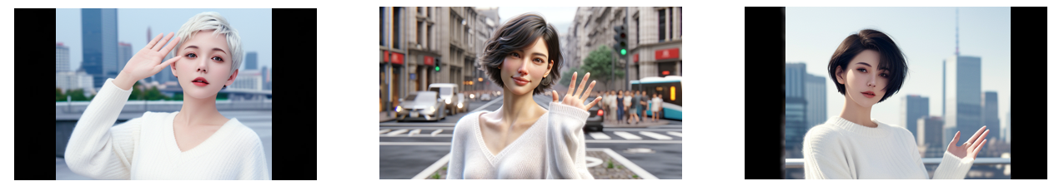

### Pose Image

Pose image control implies that the model can receive an image depicting a specific pose or a pose skeleton, depending on what was utilized during training, as input. Subsequently, the model can generate an image replicating the same pose. Unlike text prompts, pose images can provide much more specific and accurate details.

The figure illustrates a brief example of pose image control. The input is a pose skeleton, and the model is capable of generating an image that replicates the same pose.

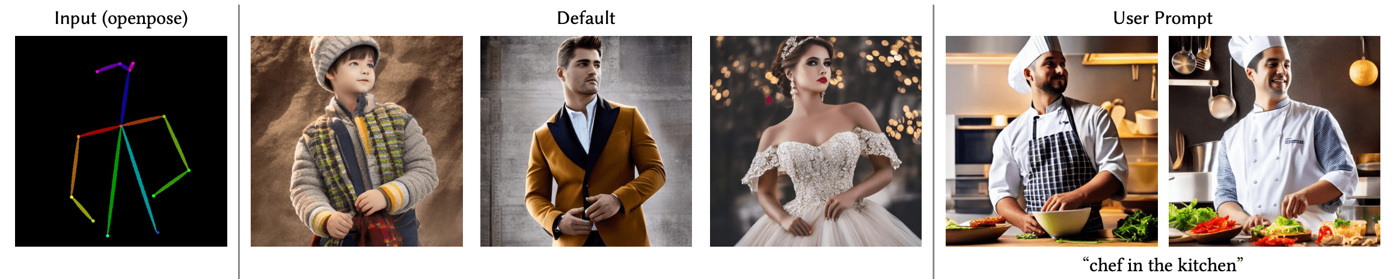

Consistency Control

As the project aims to generate video using image frames with high consistency, it is imperative to develop a model capable of high consistency in image generation. This model must retain information about the items and the background and use it to reproduce the same objects and backgrounds while enabling slight pose changes in the figure within the video. The generation process starts with a random Gaussian sample noise image, which is incrementally denoised. Consequently, each step of the model might only recognize a brief segment of the entire transition from a noise image to the output image, and treating the entire image as a unified whole. It is challenging to determine whether the model genuinely understands and segregates the components of the background or the figure. This complexity underscores that extracting and retaining specific information from the model is not a straightforward issue to resolve.

Regarding pose control, it primarily focuses on the human figure, generating varying poses based on the provided pose image. This focus suggests that if we decipher how the control mechanism functions, we could potentially isolate the model's component that governs the figure. Subsequently, extracting the component focused on the figure would inherently define the remaining component as concentrating on the background. And then we could help the model to understand and retain the specific information.

# Implementation

Base Model Implementation

We have selected Stable Diffusion V1.5 as the base model for our upcoming project. Below is a detailed description of how the Diffusion model operates, segmented into three primary components: pixel space, latent space, and conditioning.

Pixel Space: This segment handles the transformation of a pixel image, which humans can comprehend, into data that the computer can process. During this transformation, the data is compressed and interpreted to extract only the necessary information, thus enhancing training efficiency.

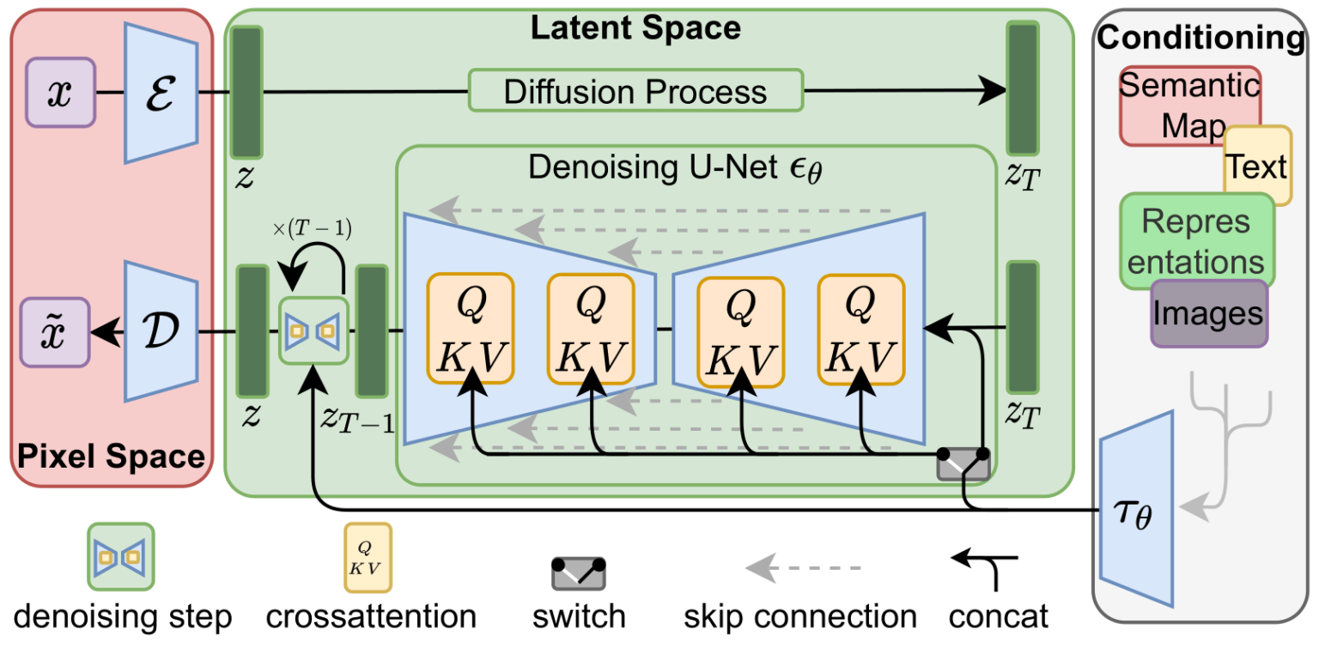

Latent Space: Serving as the core of the diffusion model, the latent space contains all information pertinent to the generation process acquired during the training phase. It is comprised of multiple layers of U-Net—a U-shaped convolutional neural network—linked by activation functions. The model learns the relationship between the text prompt and the image, simulating the effect of covering the image with random Gaussian noise and storing this data within the latent space.

Conditioning: This component converts and interpretates various types of input into a uniform format, subsequently integrating this information into the latent space to condition the image generation process.

During the training process, a pair of text prompts and images serve as inputs; these are compressed and encoded via an encoder, then transferred to the latent space. Each U-Net layer incrementally adds random noise to the image, ultimately rendering it unrecognizable to humans. Simultaneously, each layer learns to predict the appearance of the image after removing the noise that it has previously added.

In the generation phase, the conditional input—whether text, images, or other forms of information—is interpreted into a format the model can comprehend and then passed through an interpreter to the latent space. The diffusion model initiates generate a random noise image produced by a Gaussian process. This noisy image is processed by the latent space, where each U-Net layer attempts to predict and refine the final image based on the conditioned input by removing random noise. Following this iterative process, we could get the final image. And that would be decoded into a format that humans can understand by the pixel space.

Details Control Implementation

To achieve detailed control, we must train the model to learn and precisely extract features from the input image, essentially requiring the model to overfit to this image. This level of specificity could potentially compromise the diffusion model's effectiveness in other tasks. A viable solution is to train a separate diffusion model specifically overfitted to our input image and integrate it with the base model for tasks requiring detailed control.

However, as the model only needs to overfit a limited number of items or images, a large and complex model is unnecessary. Integrating this separate control model with the base model into a compatible matrix structure. Smith et al. (2020) propose an efficient method for this adaptation, termed "Low-Rank Adaptation of Large Language Models" (LoRA). This approach utilizes two low-rank matrices, A and B, during training. These matrices help significantly reduce training time and resource consumption by limiting the number of parameters adjusted. During the generation process, using convolution operations, the new matrix can be seamlessly merged into the initial matrix W.

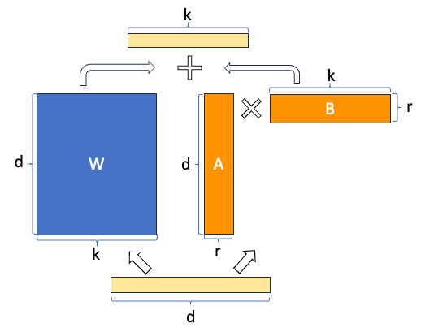

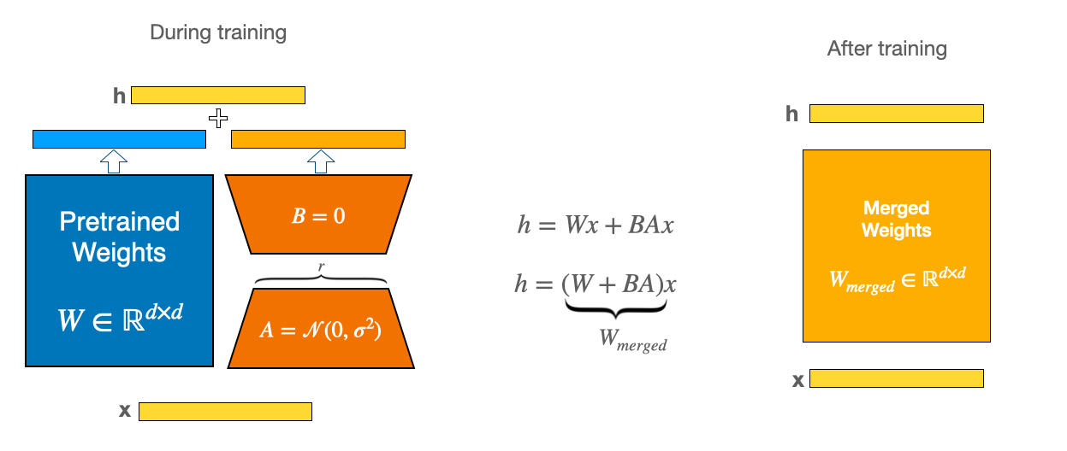

Figure from (<https://www.linkedin.com/pulse/lora-low-rank-adaptation-efficient-fine-tuning-large-language>)

By employing the LoRA technique, we can train an overfitted model with minimal resources.

Figure below illustrates how LoRA operates and the results when integrating the LoRA model with our base model. We used several style images to train the LoRA model, and upon adding it to the base model, we successfully generated high-quality images featuring the desired attributes, such as replicating a specific face from the input.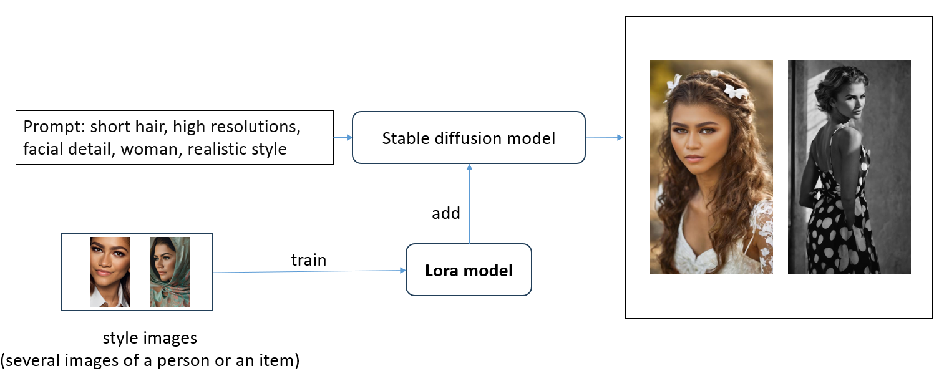

Pose Control Implementation

To achieve effective pose control, ControlNet serves as a powerful tool. As previously mentioned, the diffusion model incorporates a U-Net structure, which is a specific type of convolutional neural network (CNN).

The figure below illustrates how ControlNet functions. 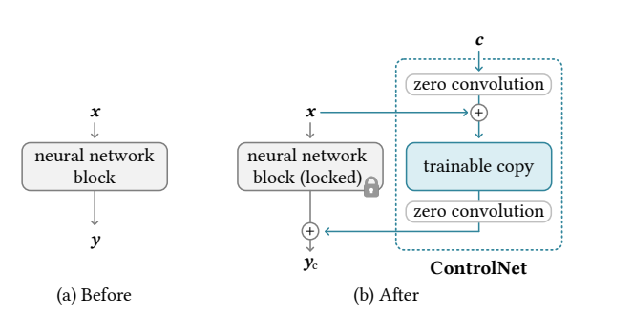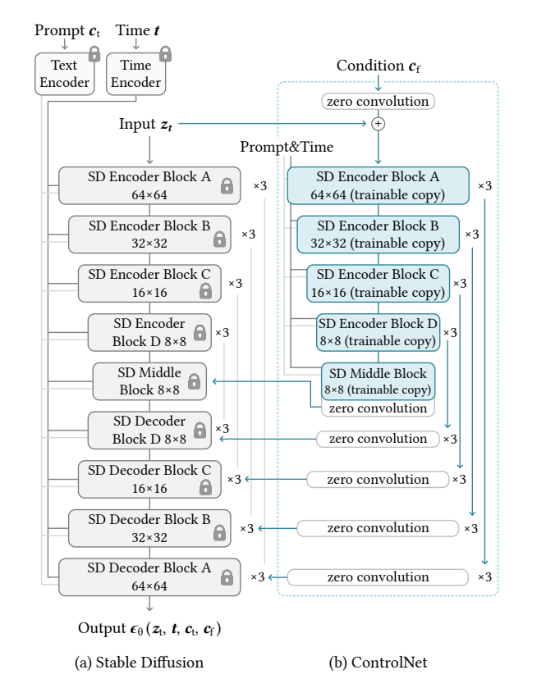

During the training process, we initially obtain a trainable copy of the original diffusion model. We then lock the original diffusion model to preserve its ability to generate high-quality images. The term 'zero convolution' refers to the initial convolution matrix being filled with zeros, which facilitates faster backpropagation during training. The input for this process consists of pose skeleton-image pairs, and the ControlNet model learns the relationship between the image and the pose skeleton.

Although the training process for ControlNet is significantly smaller and faster than training a full diffusion model, it still requires substantial resources. Therefore, we have decided to use an Openpose control model as the base for our ControlNet model.

Figure below illustrates how control net operates and the results when integrating the control net model with our model.

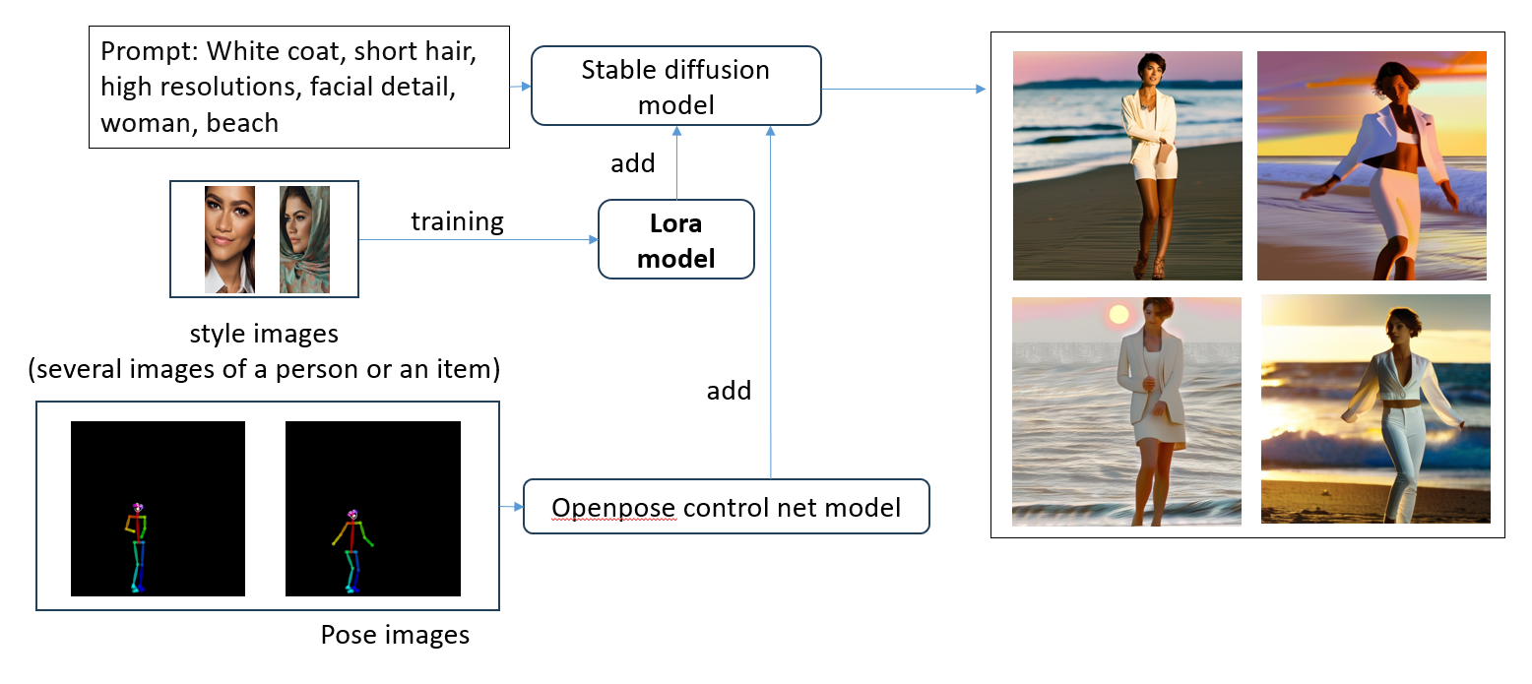

Consistency Implementation

### Similar Latent

We observe that the latent space is composed of multiple components, including the ControlNet and others. And as previously discussed, ControlNet specifically targets the figure.

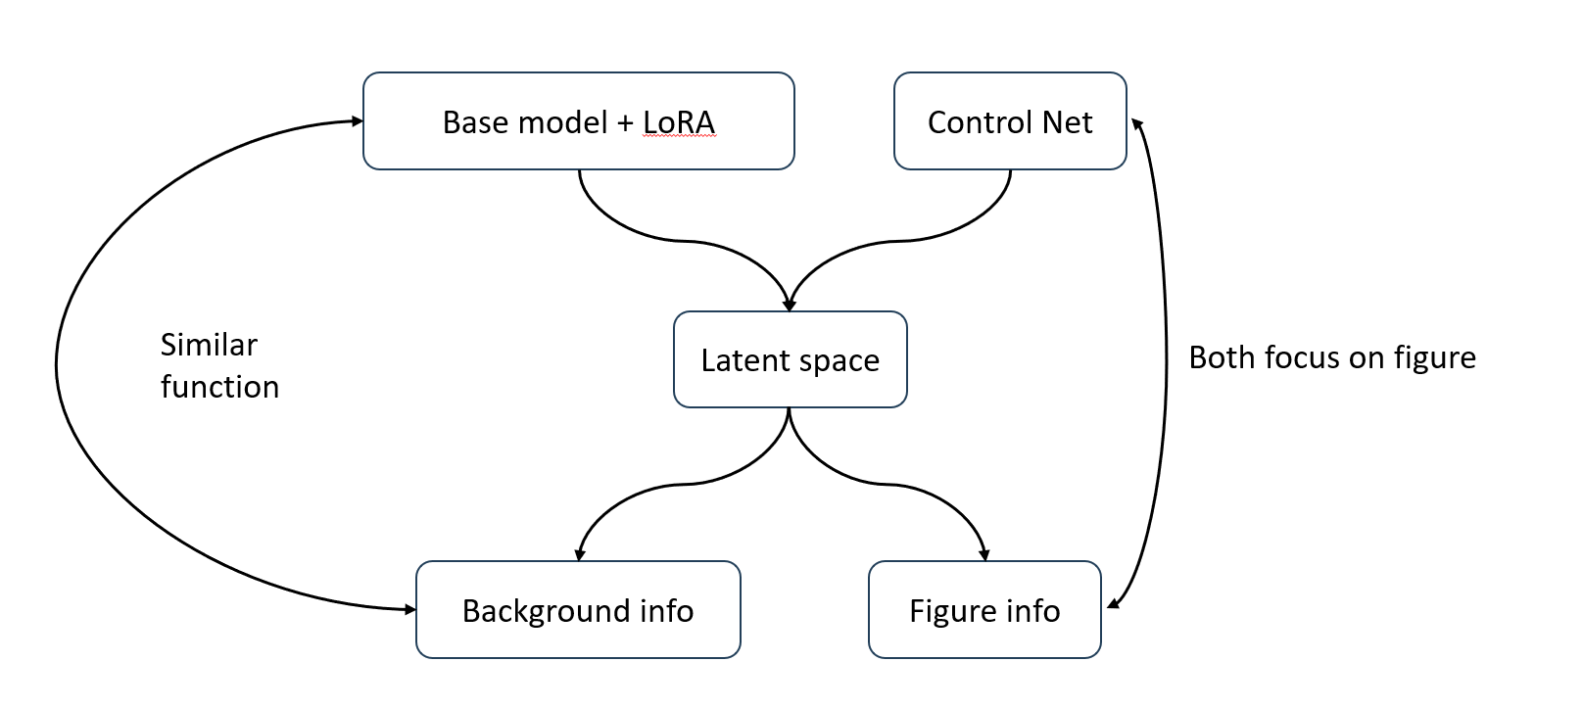Assuming the latent space can be segmented into two distinct parts—the background and the figure—it is reasonable to conjecture that the figure part aligns closely with the ControlNet component, given their shared focus on the figure’s position within the image. T It is then plausible to hypothesize that the remaining portion of the latent space, which includes the base model and the LoRA information, functions similarly to the background information.

Thus, we propose extracting the remaining information by removing the ControlNet part.

We assume that this remaining information and the background information share a similar function, specifically in determining the generation process of the background. This extracted information would then be incorporated into the generation process of subsequent frames.

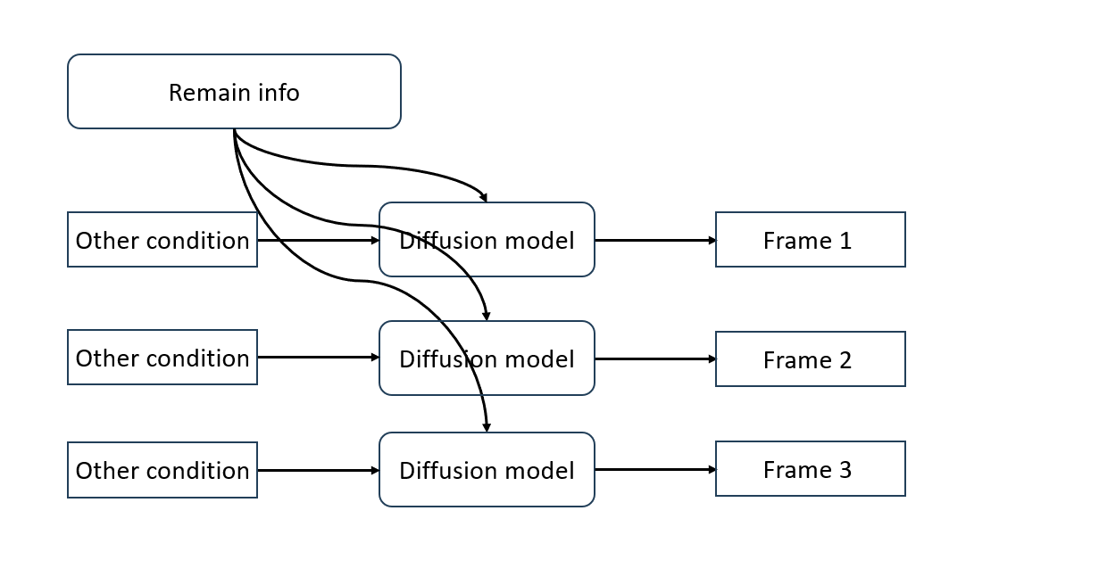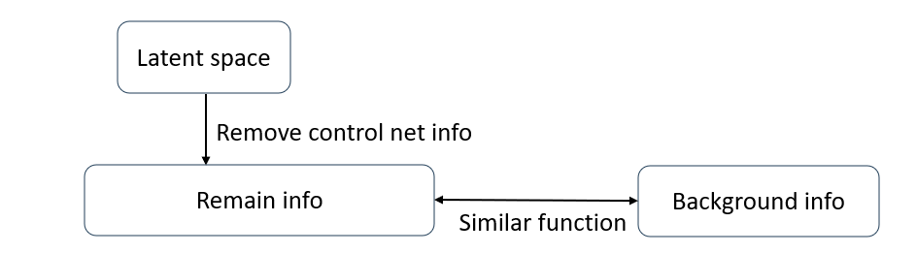The results, after applying similar latent parameters, reveal that the background remains nearly consistent across different frames.

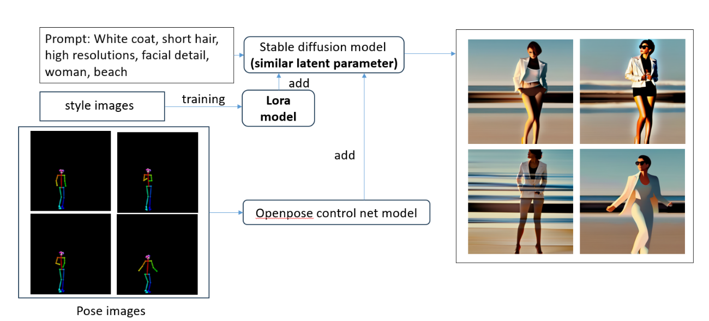However, variations are still noticeable, particularly in the figure segment where details such as clothing and facial features continue to change. This observation suggests that similar latent parameters alone are insufficient for maintaining complete consistency across frames.

### Cross-Frame Attention

It appears that removing the ControlNet component results in the loss of figure information in subsequent frames' generation processes. Let's examine the diffusion model more closely to solve this phenomenon.



The latent space of the diffusion model, particularly within each matrix of the U-Net, information is categorized into three components: 'Query' (Q), 'Key' (K), and 'Value' (V).

The Query represents the current condition or requirement to be addressed, the Key encapsulates keywords from the dataset for comparison with the Query, and the Value contains the actual content desired, storing parameters related to the item represented by the Key. This process is known as the self-attention mechanism, which calculates the relevance of each Key to the Query, typically via a dot product, resulting in a set of weights. These weights then inform the output, emphasizing the data most relevant to the Query.

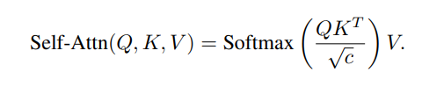During our video frame generation, we aim to produce different poses in each iteration, with varying pose images as inputs. Each pose image is interpreted, encoded, and subsequently stored in the Query (Q). However, we face challenges in consistency across frames. The second frame's generation process might select a different Key, hence a different Value, dominating the generation process and leading to variations in figure details. For example, the prompt may include 'white clothes,' but multiple variants of white clothes matching the prompt could lead to random selections by the model each time.

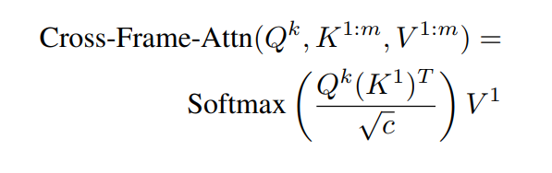To address this, we could modify the self-attention mechanism to a cross-frame attention mechanism, using the same Key and Value from the first frame to generate the subsequent frames. This approach ensures consistency in the details of the object across different frames.

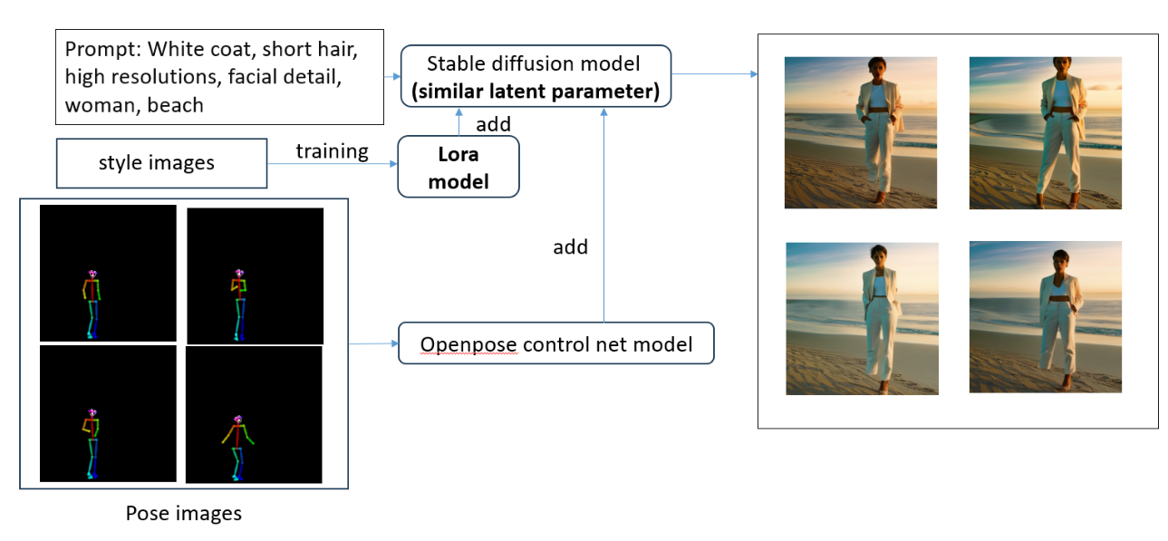Finally, we could get a highly consistency image generating model.

Summary

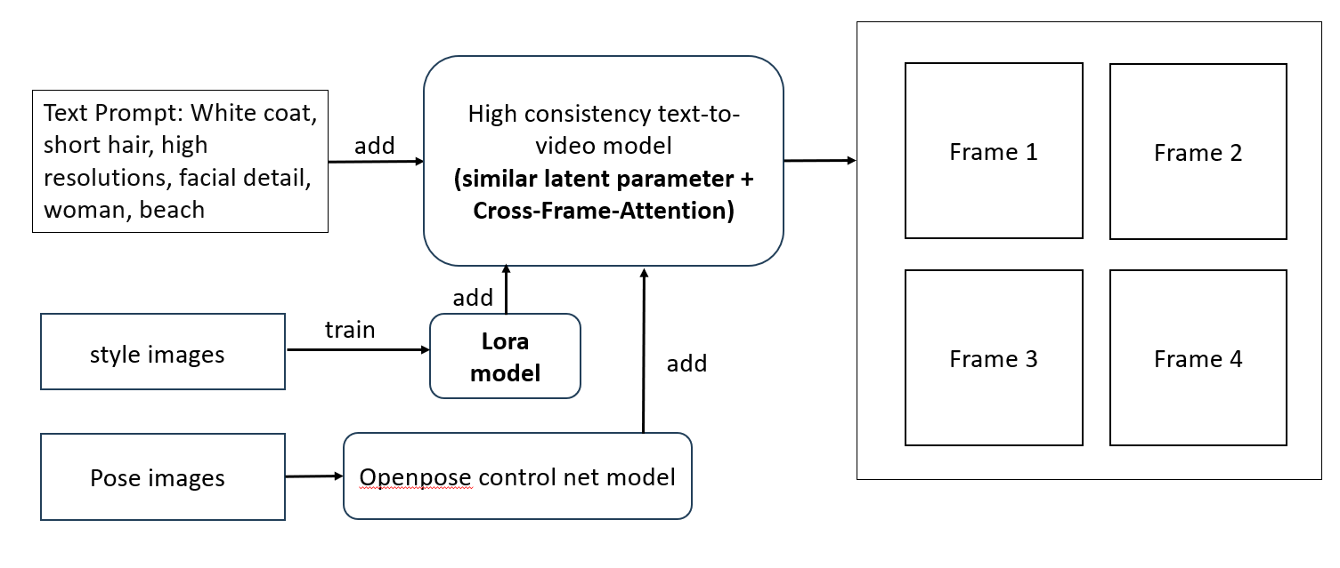This is the final pipeline review.

The baseline approach employs a text-to-image (T2I) diffusion model to generate high-resolution images. Text prompts, along with LoRA technology and ControlNet technology, are integrated to enhance detail control with greater flexibility and precision during the image generation process.

For maintaining consistency across frames, we implement similar latent representations and cross-frame attention mechanisms.

Based on this design framework, we can efficiently produce a controllable pose guide video at a reduced cost and within a shorter time.

Improvement

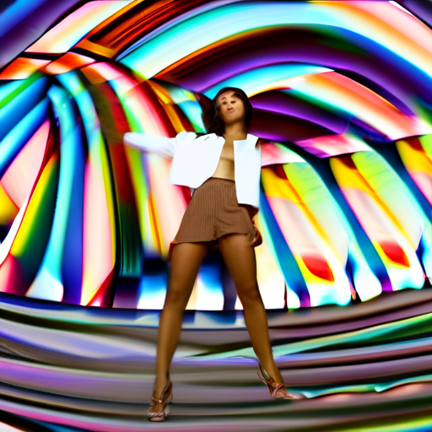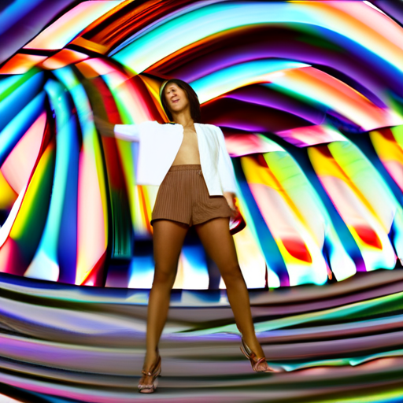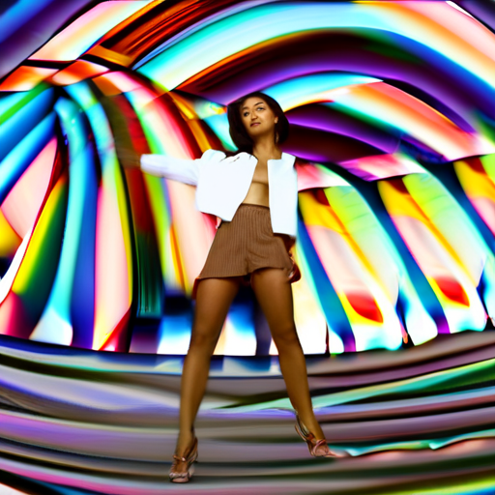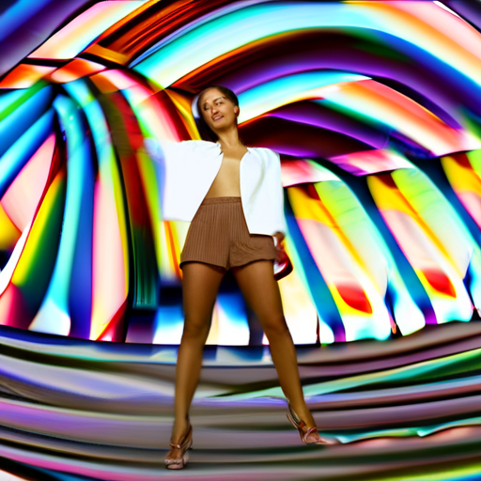Below are sample images generated by the initial version of the project.

Blurry faces, meaningless backgrounds, and distorted limbs—despite the high resolution, the overall performance of these images is poor. Such quality falls short of the standards expected by companies and individuals for integration into an initial video.

As observed, although the project appears to meet specific objectives—static backgrounds, consistent clothing details, and enhanced image resolution—the images themselves are substandard. The model potentially has the capability to generate high-quality images, but it requires proper refinements to improve performance.

Better Prompt

An effectively crafted prompt significantly enhances outcomes. Clearly and specifically describing a subject is beneficial. Additionally, assigning varying weights to key prompts can further refine the results.

Often, employing negative prompts that explicitly exclude undesirable features, such as broken arms, broken legs, or blurry faces, can substantially improve the quality of the generated images.

## Pose Skeleton with Face

To enhance facial details, the integration of a pose skeleton with facial features is advantageous. Notably, the pose control net model is specifically trained to recognize a particular type of pose skeleton. This specificity suggests that we need a distinct control model, trained on poses that include facial details to improve image quality.

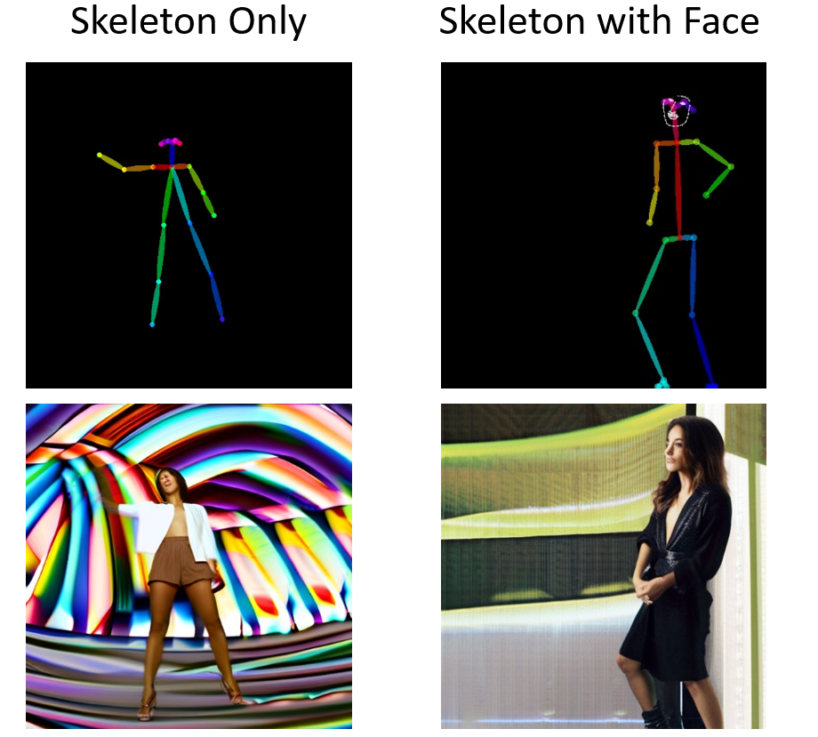

# Evaluation

The figure below presents examples of images generated by different models using the same prompt and condition image. Both the Image-to-Image (I2I) model and the Tune-a-Video model can generate relevant, high-quality images based on the condition; however, inconsistencies and noise remain prevalent. The Pose-guided Video Generation model exhibits the most impressive performance.

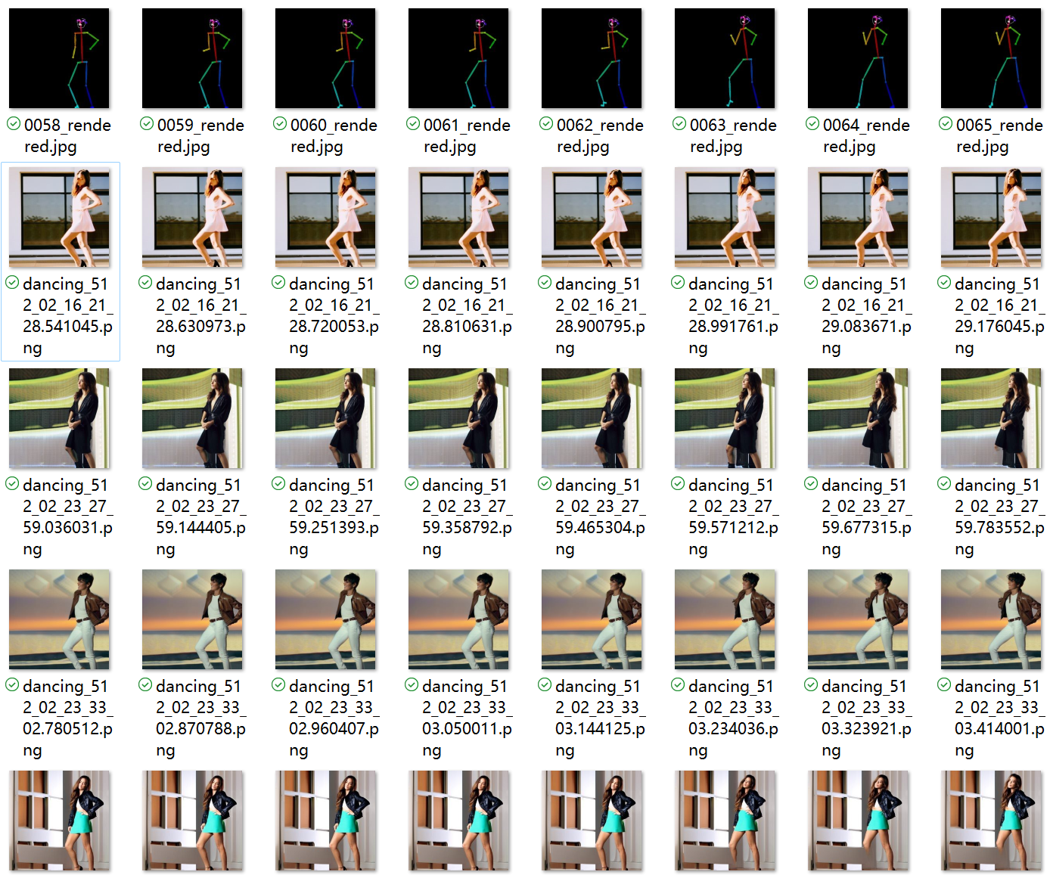Pose images.

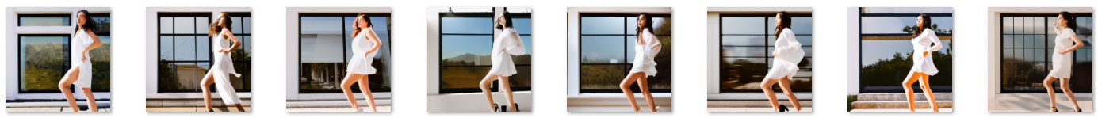Image to Image model.

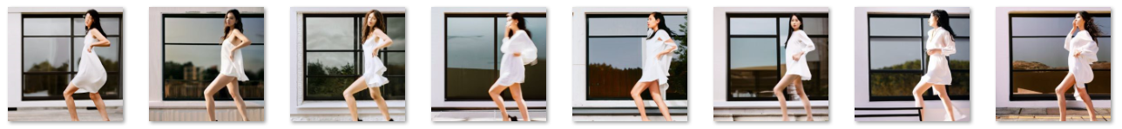Tune-a-Video.

Ours (Pose-guided Video Generation).

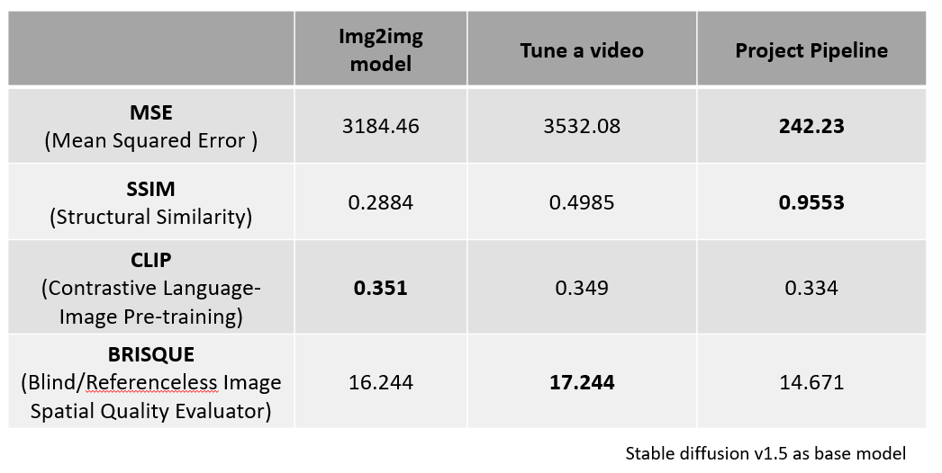The figure displays the quantitative metrics for the images, highlighting the best performance in bold. Our project achieves optimal performance in maintaining similarity, despite a slight reduction in the image quality compared to the initial model.

# Conclusion

Achievement

We propose a novel method that maintains similar latent characteristics while modifying the Self-attention mechanism into a Cross-frame Attention mechanism, aimed at constructing a highly consistent text-to-video model. This approach may address issues related to background noise and other aspects of image generation.

Additionally, we introduce a new technique for generating video using the Pose-guided Video Generation model. This model is capable of producing images with high consistency, enhanced detail accuracy, and flexible control, while maintaining satisfactory image quality.

Furthermore, the Pose-guided Video Generation model can generate video frames using limited computing resources by leveraging existing text-to-image models. This provides a pathway for companies or individuals to create custom initial videos and improve them with existing advanced image enhancement tools to produce high-quality videos.



Existing Problems

The quality of the images generated by our model does not yet compare to that of state-of-the-art models.

There are inherent conflicts within the style image control component, as the model fails to segment style images into discrete categories such as background, face, and clothes, and subsequently apply them individually. For instance, when style images of the face, clothes, and background, which have different colors, are provided simultaneously, the model might recognize the face style image by learning from the corresponding prompt, such as black face. However, this recognition is not sufficiently clear during the generation process, potentially leading to blurred images or a lack of detail.

Future Works

To enhance the quality of image generation, the 'Segment Anything' technique offers a potential solution. Developed by Kirillov et al. (2023), this powerful tool can identify and isolate individual elements within an image. By utilizing this technique, we can selectively apply style images' influences to appropriate segments of the image. For instance, by accurately identifying clothing segments, we can generate these sections to closely match the style images of clothes. This approach could minimize conflicts between different style segments and preserve more details from the style images.

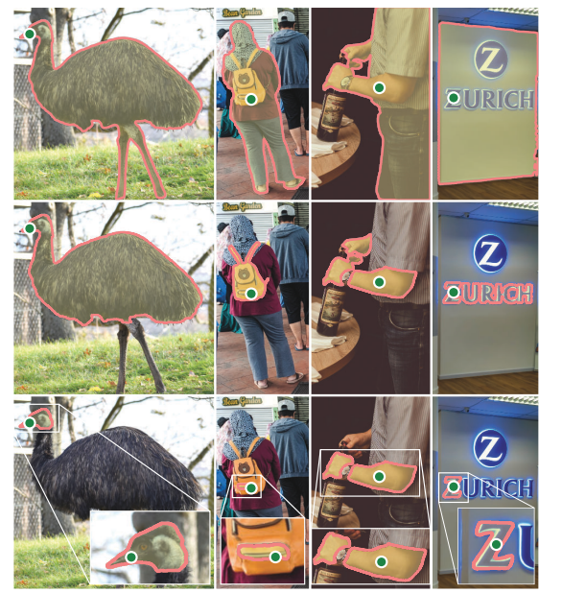

References

Balaji, Y., et al. "ediff-i: Text-to-image Diffusion Models with an Ensemble of Expert Denoisers." 2022.

Betker, J., et al. "Improving Image Generation with Better Captions." 2023. <https://cdn.openai.com/papers/dall-e-3.pdf>.

Blattmann, A., et al. "Stable Video Diffusion: Scaling Latent Video Diffusion Models to Large Datasets." arXiv preprint arXiv:2311.15127, 2023a.

Blattmann, A., et al. "Align Your Latents: High-Resolution Video Synthesis with Latent Diffusion Models." 2023b.

Brooks, T., et al. "Instructpix2pix: Learning to Follow Image Editing Instructions." Proceedings of the IEEE/CVF Conference on Computer Vision and Pattern Recognition. 2023, pp. 18392-18402.

Carlini, N., et al. "Extracting Training Data from Diffusion Models." 32nd USENIX Security Symposium (USENIX Security 23). 2023, pp. 5253-5270.

Carion, N., et al. "End-to-end Object Detection with Transformers." European Conference on Computer Vision. Springer, 2020, pp. 213-229.

Changpinyo, S., et al. "Conceptual 12m: Pushing Web-scale Image-text Pretraining to Recognize Long-tail Visual Concepts." 2021 IEEE/CVF Conference on Computer Vision and Pattern Recognition (CVPR). 2021, pp. 3557-3567.

Chen, D., et al. "Bfloat16: The Secret to High Performance on Cloud TPUs." 2019. <https://cloud.google.com/blog/products/ai-machine-learning/bfloat16-the-secret-to-high-performance-on-cloud-tpus?hl=en>.

Chen, M., et al. "Training-free Layout Control with Cross-attention Guidance." arXiv preprint arXiv:2304.03373. 2023.

Deng, J., et al. "Imagenet: A Large-Scale Hierarchical Image Database." Proceedings of the IEEE/CVF Conference on Computer Vision and Pattern Recognition. IEEE, 2009, pp. 248-255.

Gal, R., et al. "An Image is Worth One Word: Personalizing Text-to-Image Generation using Textual Inversion." International Conference on Learning Representations. 2022.

Goodfellow, I., et al. "Generative Adversarial Nets." Advances in Neural Information Processing Systems, 27. 2014.

Han, L., et al. "Svdiff: Compact Parameter Space for Diffusion Fine-Tuning." arXiv preprint arXiv:2303.11305. 2023.

He, K., et al. "Deep Residual Learning for Image Recognition." Proceedings of the IEEE/CVF Conference on Computer Vision and Pattern Recognition. 2016, pp. 770-778.

Hertz, A., et al. "Prompt-to-Prompt Image Editing with Cross-Attention Control." International Conference on Learning Representations. 2022.

Ho, J., et al. "Denoising Diffusion Probabilistic Models." Advances in Neural Information Processing Systems, 33: 6840-6851. 2020.

Karras, T., et al. "A Style-Based Generator Architecture for Generative Adversarial Networks." Proceedings of the IEEE/CVF Conference on Computer Vision and Pattern Recognition. 2019, pp. 4401-4410.

Kingma, D. P., and Welling, M. "Auto-Encoding Variational Bayes." International Conference on Learning Representations. 2014.

Kumari, N., et al. "Multi-concept Customization of Text-to-Image Diffusion." Proceedings of the IEEE/CVF Conference on Computer Vision and Pattern Recognition. 2023, pp. 1931-1941.

Li, Y., et al. "Gligen: Open-set Grounded Text-to-Image Generation." Proceedings of the IEEE/CVF Conference on Computer Vision and Pattern Recognition. 2023, pp. 22511-22521.

KondratyukDan, et al. "Videopoet: A Large Language Model for Zero-Shot Video Generation." arXiv preprint arXiv:2312.14125. 2023.

Kumari, N., et al. "Multi-concept Customization of Text-to-Image Diffusion." Proceedings of the IEEE/CVF Conference on Computer Vision and Pattern Recognition. 2023, pp. 1931-1941.

Li, Y., et al. "Gligen: Open-set Grounded Text-to-Image Generation." Proceedings of the IEEE/CVF Conference on Computer Vision and Pattern Recognition. 2023, pp. 22511-22521.

Ma, Xin, et al. "Latte: Latent Diffusion Transformer for Video Generation." arXiv preprint arXiv:2401.03048. 2024.

Sharma, Piyush, et al. "Conceptual Captions: A Cleaned, Hypernymed, Image Alt-Text Dataset for Automatic Image Captioning." ACL. Jan 2018.

Schuhmann, Christoph, et al. "Laion5b: An Open Large-Scale Dataset for Training Next Generation Image-Text Models." NeurIPS. 2022, pp. 25278-25294.

Wang, Xiang, et al. "Videocomposer: Compositional Video Synthesis with Motion Controllability." NeurIPS. 36, 2024.

Wang, Jiuniu, et al. "Modelscope Text-to-Video Technical Report." arXiv preprint arXiv:2308.06571. 2023.

Xiong, Wei, et al. "Learning to Generate Time-Lapse Videos Using Multi-Stage Dynamic Generative Adversarial Networks." CVPR. 2018, pp. 2364-2373.

Xue, Hongwei, et al. "Learning Fine-Grained Motion Embedding for Landscape Animation." Proceedings of the 29th ACM International Conference on Multimedia. 2021, pp. 291-299.

Rombach, R., Blattmann, A., Lorenz, D., et al. "High-Resolution Image Synthesis with Latent Diffusion Models." Proceedings of the IEEE/CVF Conference on Computer Vision and Pattern Recognition. 2022.

Ruiz, N., Li, Y., Jampani, V., et al. "Dreambooth: Personalized Image Generation through Fine-Tuning Techniques." arXiv preprint.

Ma, Y., He, Y., Cun, X., et al. "Follow Your Pose: Pose-Guided Text-to-Video (T2V) Generation Using Pose-Free Videos." Offers a novel method for creating dynamic and accurate poses in video generation.

Ma, Liqian, et al. "Pose-Guided Person Image Generation." Proposes a network for generating images based on a reference image and a specified pose. Focuses on a two-stage process concentrating on global human body structure and appearance details.

Zhang, L., Rao, A., Agrawala, M. "Adding Conditional Control to Text-to-Image (T2I) Diffusion Models." Proceedings of the IEEE/CVF International Conference on Computer Vision. 2023. Introduces ControlNet for adding conditional control to text-to-image (T2I) diffusion models, enhancing capabilities for various input conditions.

Appendix A - Example

More examples (all the images are included in the support material folder)

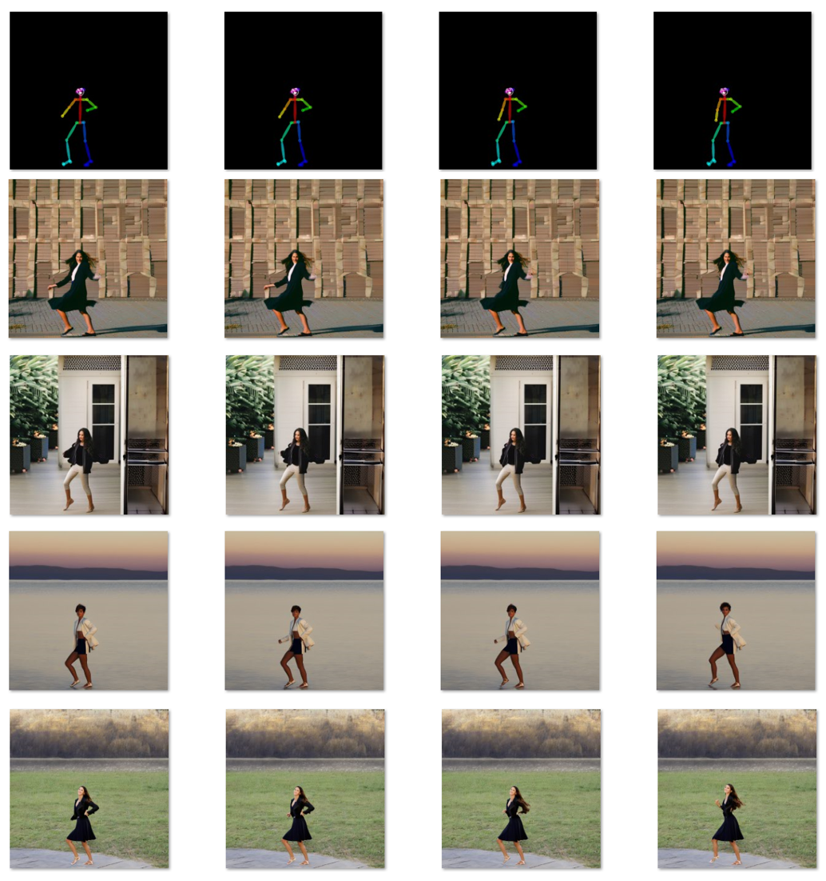

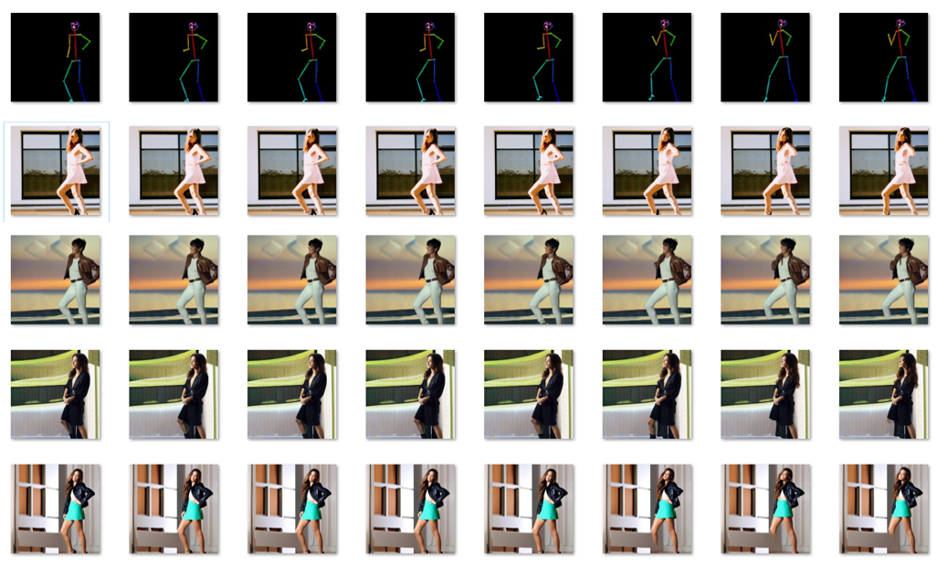

Additional Appendices (as needed)

Environment

**Ubuntu 16.04**

**Python programming language**

**OpenCV**

**GPU Nvidia V100 *4 32GB**

Model

**Stable-Diffusion Model v1.5.**

**Openpose Control-Net Model**